|  |  |
| --- | --- |
| https://lh4.googleusercontent.com/8UjDB1qP9JZzOPmaFcUcfStMVZ8VpptSxvP2gLI4YEgiQjYcR_cNonqtNuPXhrQgV8bh6KhEcLSyw65PBxk4I_MmEGS12guoUS4zmc4dB_Rpw37rALtJJ1pTRzylHuZjGbOKaMo | **FPT ACADEMY INTERNATIONAL**  **FPT – APTECH COMPUTER EDUCATION** |

**Centre Name: ACE-HCMC-2-FPT.**

**Address: 590 Cach Mang Thang 8, District 3, Ho Chi Minh City, Viet Nam.**

**Beauty Services**

|  |  |  |
| --- | --- | --- |
| **Supervisor:** | Phạm Thị Lánh | |
| **Term:** |  | |
| **Batch No:** | T1.2108.A0 | |
| **Group No:** | Group 3 | |
| **Order:** | **Full name** | **Roll No.** |
| 1. | Nguyễn Lê Thuận | Student1322490 |
| 2. | Huỳnh Ngọc Thái | Student1317113 |

December 2021



This is to certify that

**Mr**. Nguyễn Lê Thuận

Huỳnh Ngọc Thái

Has successfully Designed &

Developed _ _ _ _ _ _ _ _ _ _ _ _

Submitted by: Phạm Thị Lánh

Date of Issue: _ _ _ _ _ _ _ _ _ _

 Authorized Signature:_ _ _ _ _

**Contents 1**

**1 ACKNOWLEDGEMENT.....................................................................................................5**

**2 SYNOPSIS..........................................................................................................................6**

**3 REVIEW 1 ..........................................................................................................................7**

**3.1 REQUIREMENT SPECIFICATION ............................................................................8 3.2 PROBLEM DEFINITION .......................................................................................... 9 3.3 CUSTOMERS REQUIREMENT SPECIFICATION (CRS) ....................................... 10 3.4 ARCHITECTURE & DESIGN OF THE SYSTEM.....................................................12 3.5 SITEMAP ...................................................................................................................13 3.6 WEBSITE LAYOUT....................................................................................................14**

3.6.1 HOMEPAGE …………………………………………………………………………14

3.6.2 ABOUT US ………………………………………………………………………......21

3.6.3 CONTACT US...................................................................................................22

**3.7 TASK SHEET 1………………………………………………………………………….....23**

**4 REVIEW 2 ........................................................................................................................24**

**5 PROJECT SNAPSHOTS..................................................................................................25**

**5.1 Home Page………………………….............................................................................25**

**5.2 Makeup Atrist………………………............................................................................26**

**5.3 Details Page…………………………...........................................................................26**

**5.4 Video…………………………………............................................................................29**

**5.5.About US……………………………….........................................................................30**

**5.6 Contact ………………………………...........................................................................30**

**5.7 Footer…………………………………..........................................................................31**

**6 USER MANUAL……….....................................................................................................32**

**6.1 System Requirement…………………………..............................................................32**

**6.2 Step by Step Instructions:…………………………......................................................32**

6.2.1 Strarting Home Page ………………………………………………………………..32

6.2.2 Makeup Artist Page ………………………………………………………………....33

6.2.3 Details Page………………………………………………………………………...34

6.2.4 Video Page..………………………………………………………………………...38

6.2.5 About Us…..………………………………………………………………………...38

6.2.6 Contact Us.……………………………………………………………………….....39

6.2.7 Footer……...………………………………………………………………………...39

**7 TASK SHEET 2……….....................................................................................................40**

**1 ACKNOWLEDGEMENT**

The world is a better place thanks to people who want to develop and lead others.

What makes it even better are people who share the gift of their time to mentor future leaders.

We would like to acknowledge all those who have given us their support and knowledge sharing in the making of this project.

We wish to express our gratitude to the e-Project Team at the Head Office in India, who provided us with guidance and instructions. We would like to thank all the staff members at the Center in India for providing us the opportunity to work on this project and offering us their upmost encouragement through out the process.

We would like to express our special thanks of gratitude to our instructor, Mrs. Pham Thi Lanh at the Aptech Computer Education HCMC for her able guidance and support in completing our project. We would also like to extend our gratitude to the staff at the Aptech HCMC office for providing us with all the facility that was required.

Our acknowledgement to several people whom also helped with: the collections of pictures samples, CSS & JS libraries, the preparation of web development, sample code snippets and tutorials and they are all thanked for their contributions. Special mentions goes to the contributors of Bootstrap 4, the contributors and admins for tutorials sites such as W3C school, Tutorialspoint.com, GeeksforGeeks, and many other learning sites.

And Lastly, to our many friends and family, you should know that your support and encouragement was worth more than we can express on paper. Thank you to our moms and dads for breakfasts, lunch and dinners – we could not have finished the project without being provided with love and daily nourishments.

**2 SYNOPSIS**

Makeup artists and what they bring to beauty products.

This is a list of the top makeup artists and their website links.

Makeup can be a different experience for everyone. It influences how you feel about yourself and what memories you want to create. The type of makeup that will work for you depends on your skin type, eye color, eye shape, hair style, age, body type, lifestyle and more. This article talks about how makeup artists come up with unique looks from colors to textures to products they use in their work every day of the week.

Makeup artists have a job to help clients feel beautiful and special for a day, a night out with friends, a senior portrait or a wedding. Makeup artists must have the knowledge of how to match the right foundation color for skin tone, what lipstick shade will enhance your lips, which eyeshadow color will make someone's eye pop and what blush will look good on someone's skin tone. Makeup artists must know all of this and more to deliver top-notch work.

You are supposed to create a website for them with the below mentioned requirement specifications:

The website is to be developed to provide certain features according to specific requirements by the management.

The website is to be developed for the Windows Platform using HTML5, JavaScript and Geolocation. The site should work well in all leading browsers including Chrome, IE, Firefox etc.

**3 REVIEW 1**

**3.1 REQUIREMENT SPECIFICATION**

**The Web site is to be created based on the following requirements.**

1. The site should have related menu categorized as per requirement.

2. The user should be able to see all the makeup artists.

3. Once the user selects the particular artists , he can see the base charge along

with the options of selecting the services like

a. Bridal Make up

*- Matte*

*- High definition*

*- Standard bridal*

b. Groom make up

c. Family make up

*- Only make up*

*- Hair styling*

*- Draping saree / Attire*

d. Touch up services

e. Siders make up: This section caters and covers the friends and

relatives if any wish to have the makeup done for the functions.

4. User can select the location and date/timing. Address of the location should

be displayed using GeoLocation API (eg. GoogleMaps)

5. Artists should also provide the information as whether they can give a demo

session for bride/groom and charges for the demo session. Demo session

should be kept as optional.

6. User can also see the sample works by the particular artists

7. Discount offers should be displayed in offers /discounts section

8. There should be review section where users can leave their reviews about

particular artist or see the already available reviews.

**3.2 PROBLEM DEFINITION**

According to consumer surveys, the majority of clients are interested in the following makeup issues:

1/ How do we locate makeup artists?

2/ What are professional makeup techniques?

3/ What are the make-up artist's services: current makeup styles, prices?,...

4/ What distinguishes one makeup artist from another?

5/ Are there a variety of haircuts and makeup accessories?

6/ Will I be able to see the makeup samples that are available?

7/ How can I schedule a consultation with that makeup artist? And there's more...

As you can see, there are a lot of questions that can't be answered online or that moderators would have a hard time answering. As a result, our website can let users find information at their own pace, which is a solution to the problem. For assistance and comparison information, the site will be referred to as a self-service website.

**3.3 CHARACTERISTICS OF CUSTOMER REQUIREMENTS (CRS)**

1. Client: Beaty Services.

2. Objectives:

o Create a website with information about makeup artists, as well as information about makeup artists based on services.

o The website should be light in color, with relevant logos and photos. A menu that shows a list of services and includes clickable links. Users may find links to the makeup artists they work with on the "Contact Us" page. If a user wishes to email us or find our physical location, they can do so on the "Contact Us" page.

o Key terms include "menu," "services," "model artist," "Menu for cosmetic services," "Menu information for make-up artists," "Table information," "Contact us," "Send Email," and "Geographic Location."

3. Input provided by the customer:

o During the "makeup artist" session, click on clickable links/images to go to third-party websites.

o Go to the "Contact Us" webpage by clicking the "Contact Us" link.

o To send us an email, click "email us."

4. Hardware Requirements:

o A Pentium 166 or higher computer system is required to access all of the tools in the courses.

o 64 megabytes of RAM or more

5. Software requirements:

o Windows 7/11 and later operating systems

o HTML5/CSS/JS-capable browsers

o Visual Studio Code is a code editor.

o Bootstrap 4 is a framework for creating websites.

o JQuery is a scripting language.

6. Scope of Work (summary):

The following requirements, which should be developed based on management's discretion, are subject to management's discretion:

o Select a picture to display, then select a menu from the drop-down menu.

o To show hyperlinks and Clickable Images, a web-based GUI will be constructed. The menus will be located on the top navigation bar and will be accessible at all times.

The menu will provide connections to the makeup artist's website and services. There will be connections to other pages as well as photos that can be clicked to take users to third-party websites.

o Users can examine and obtain links to their favorite cosmetics artists' profiles.

o There will be a page where clients may book a makeup appointment with the makeup artist of their choosing based on the services they have selected.

o A "Contact Us" button will be added to provide the user with a link to the email, and our office address will be rendered using the geolocation API contained in the HTML.

**3.4 ARCHITECTURE & DESIGN OF THE SYSTEM**

HTML

CSS

Javascripts

JQuery

HTML & Database

Bootstrap 4

Static

Assels:

(Pics, logo, banner )

Wed server

Beautyservice.com

Client Browsers

**3.5 SITEMAP**

Book

View

Book

View

View

Services

Sample

products

Sample

products

Services

Sample

products

Services

Book

About

Home

Video

Model Artist

Introduce

Contact

**3.6 WEBSITE LAYOUT**

The aesthetic on your website should be SIMPLE yet DELICIOUS. The major focus of the website will be located on the main landing page, where all information will be stored and exhibited, because the purpose is to offer information FAST and SYSTEM to website users. NS

Users will engage with the website in a variety of ways, including using the search bar to make a search, and searching for information.

The make-up artist may be seen using the drop-down menu: the makeup samples available as well as the services given.

The site will also have several free pages, such as About Us and Contact Us, which will include information about our staff and our office address.

**3.6.1 HOMEPAGE**

Our Home Landing Page is divided into three components, as shown in the diagram below:

- Top navigation bar:

The menu is the MOST IMPORTANT element of our project because it is where the User will interact the most. On the left side, in the same row as the navigation bar, there will be our Company logo, some drop down options when home is selected, a working search bar, and buttons to link to other pages on our Website.

- There are three items in the home section's menu:

+) The first page we see when we go to the web is with introduces.

+) The model artist area of the website will be a key feature, allowing users to see the makeup artists and services available.

+) Finally, there's the video section, where visitors can see the makeup application and admire the outcomes.

- The following is the main content:

The names of the make-up artists, as well as a brief description of the intro, will be included at the top of the main body. After the user has chosen the makeup artist he want, the user can click on the details button, which will offer detailed information and services for the user to review to gain a deeper understanding of the makeup artist Users can view available makeup samples by selecting "sample product," and users can view and refer to some of the makeup artist's services by clicking "service." Users can choose and make an appointment in the "book" area after selecting the needed services; they will leave the date, time, address, phone number, and so on. Users can submit evaluations in the view area if they are satisfied or if it is not about the makeup artist.

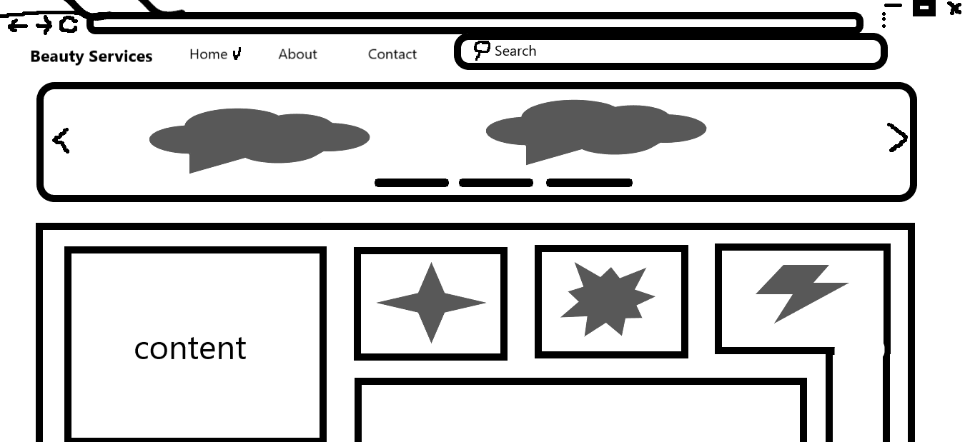

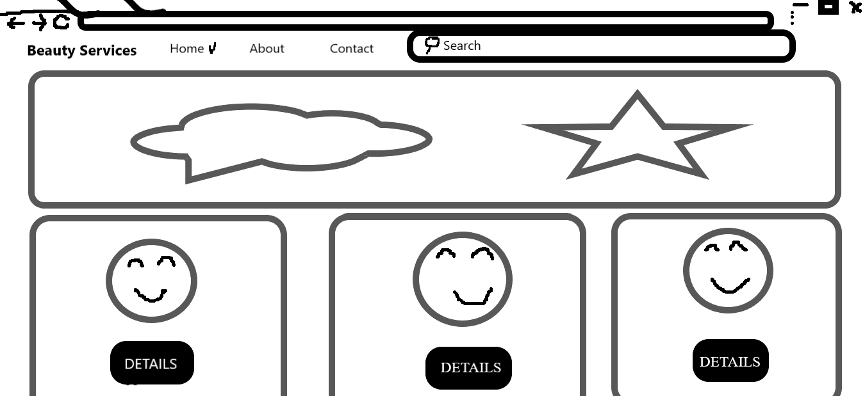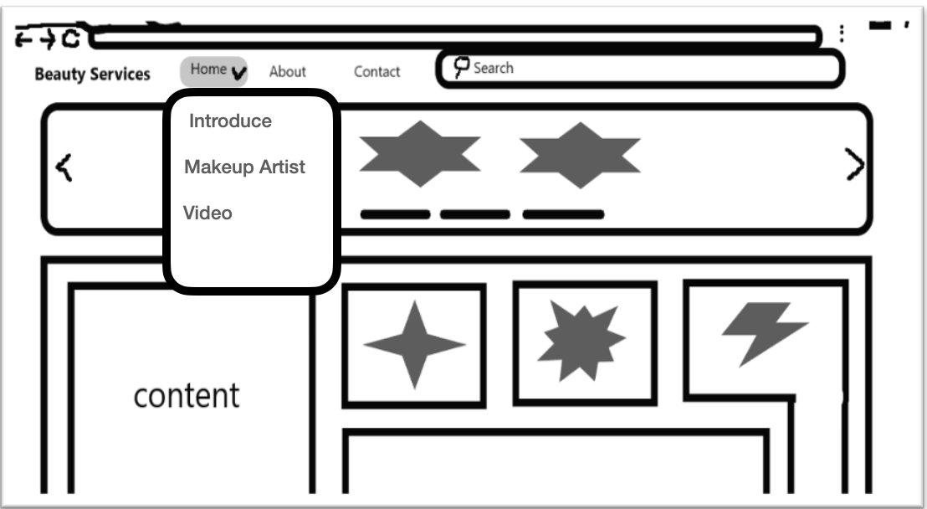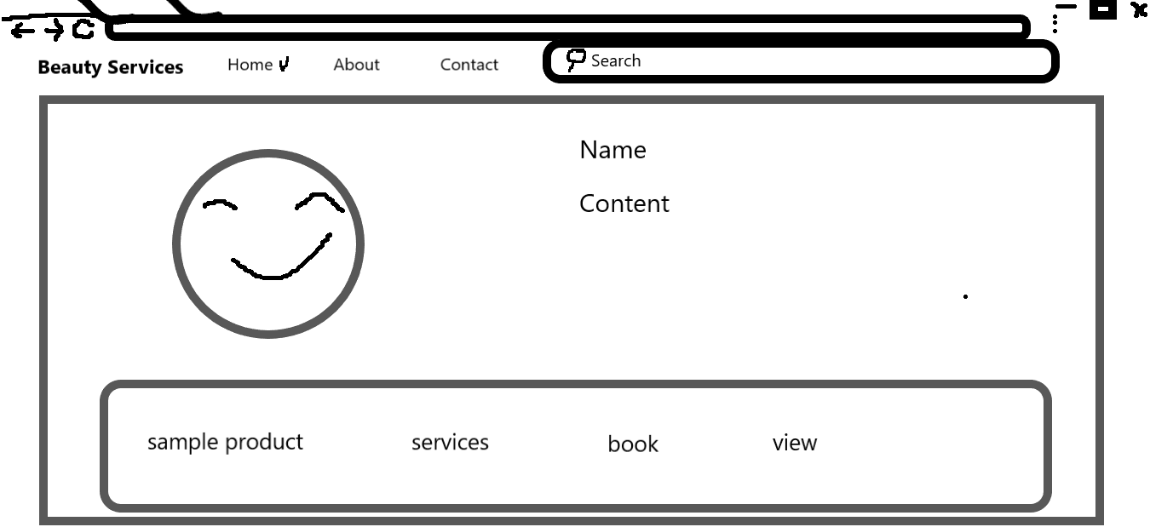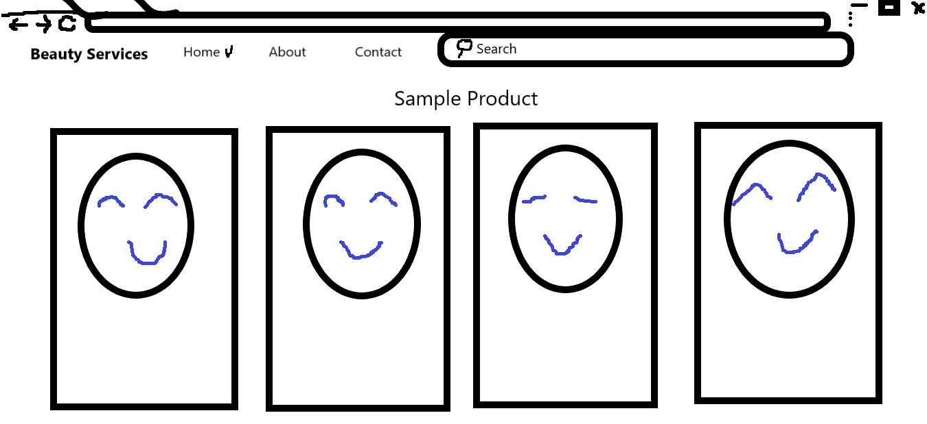

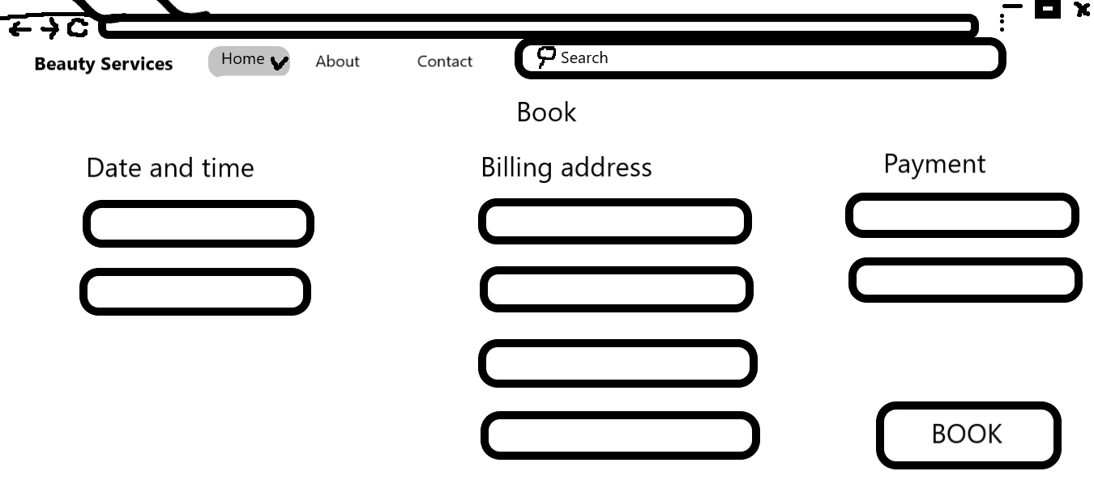

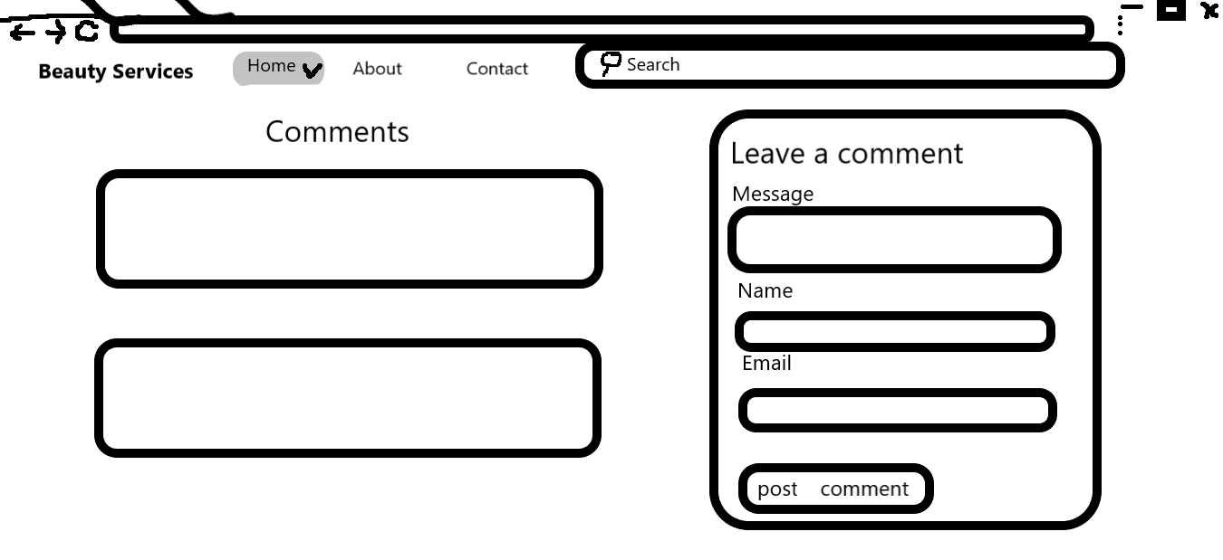

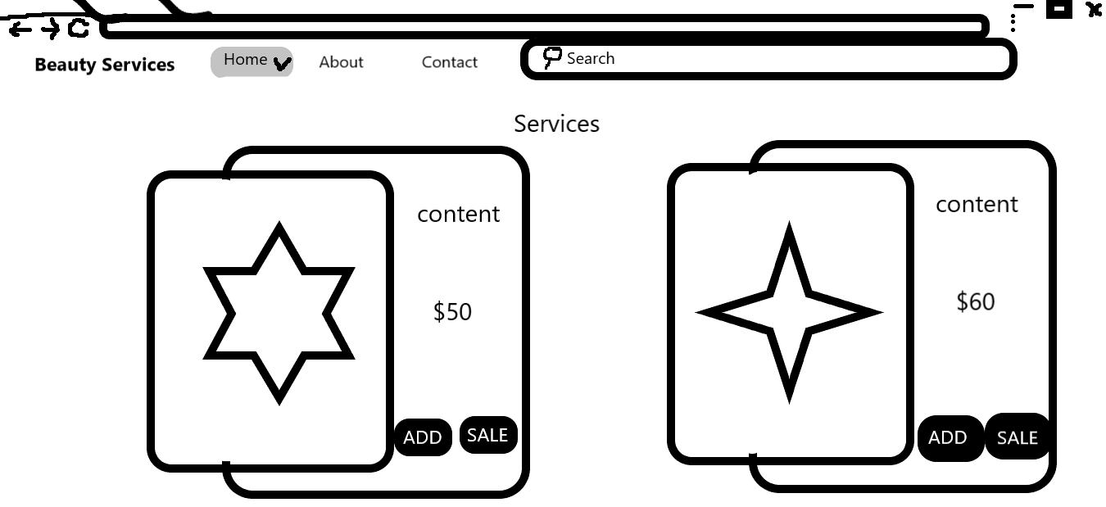

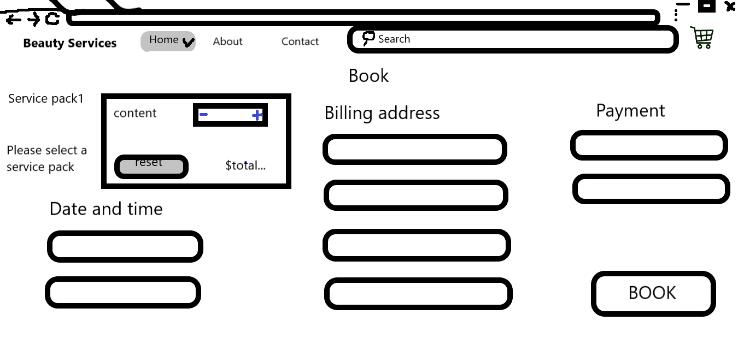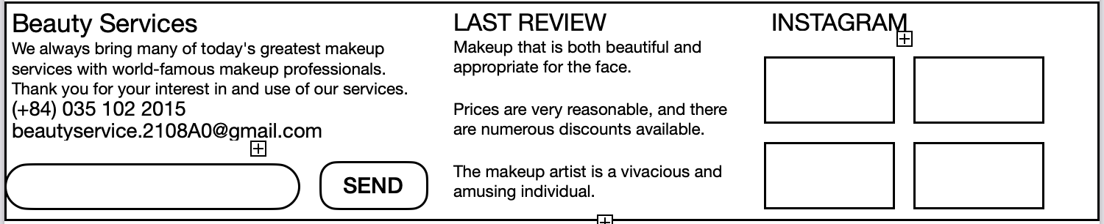

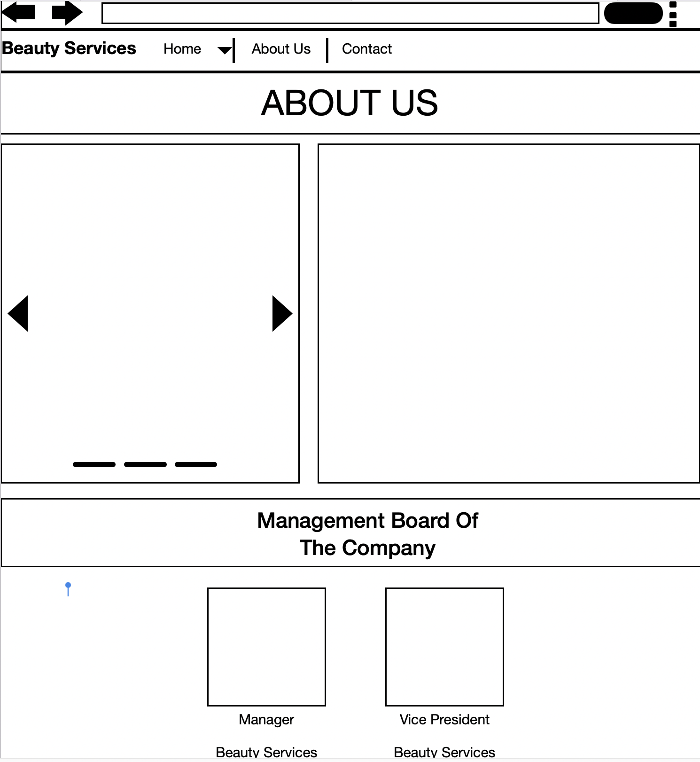**3.6.2 ABOUT US**

**3.6.3 CONTACT US**

The contact us layout will have be simple, there will be a main hero banner on top and below are the headings and email link to our office, a feedback form to be populated using Ajax, and our office address along with a geolocation API showing our office location. The top nav menu will become “Active” to show which page users are currently in.

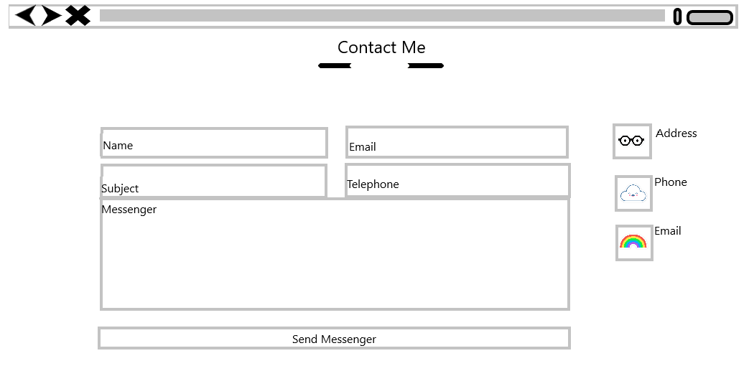

**3.7 TASK SHEET 1**

|  |  |  |  |  |  |  |
| --- | --- | --- | --- | --- | --- | --- |
| Project Ref No. | Project  Title - Ask  Me Mobile | Activity  Plan  Prepared  by | Date of preparation of Activity Plan | | | |
| Task | Actual  Start Date | Actual  Days | Teammate  Names | Status |
| Brainstorming ideas for  layouts, and Project Objective | | Thuận,Thái | 13/11/2021 | 4 days | Thuận, Thái,Trinh | Completed |
| Draw site maps and  architecture design | | Thuận,Thái | 16/11/2021 | 1 day | Thuận, Thái,Trinh | Completed |
| Wire framing general page  layout. | | Thuận,Thái | 17/11/2021 | 1 day | Thuận,Thái | Completed |
| Collect static assets (pictures,  mp4, documentation) | | Thuận,Thái | 17/11/2021 | 1 day | Thuận,Thái | Completed |
| Design & Build Home Page | | Thái | 16/11/2021 | 2 days | Thái | Completed |
| Design & Build Contact Us  Page | | Thuận | 16/11/2021 | 1 day | Thuận | Completed |
| Design & Build About Us Page | | Thuận | 16/11/2021 | 2 days | Trinh | Completed |
| Design & Build Footer Session | | Thái | 16/11/2021 | 2 days | Thái | Completed |
| Write project report Review 1  Activity | | Thuận | 18/11/2021 | 1 day | Thuận | Completed |

|  |  |
| --- | --- |
| Signature of Faculty | Signature of Team Leader |
|  |  |

**4 REVIEW 2**

**5 PROJECT SNAPSHOTS**

**5.1 Home Page**

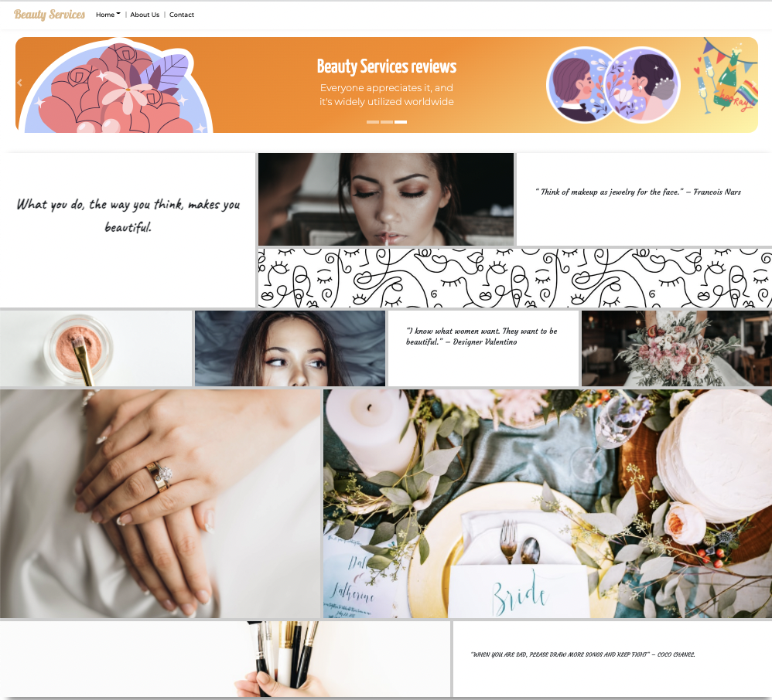

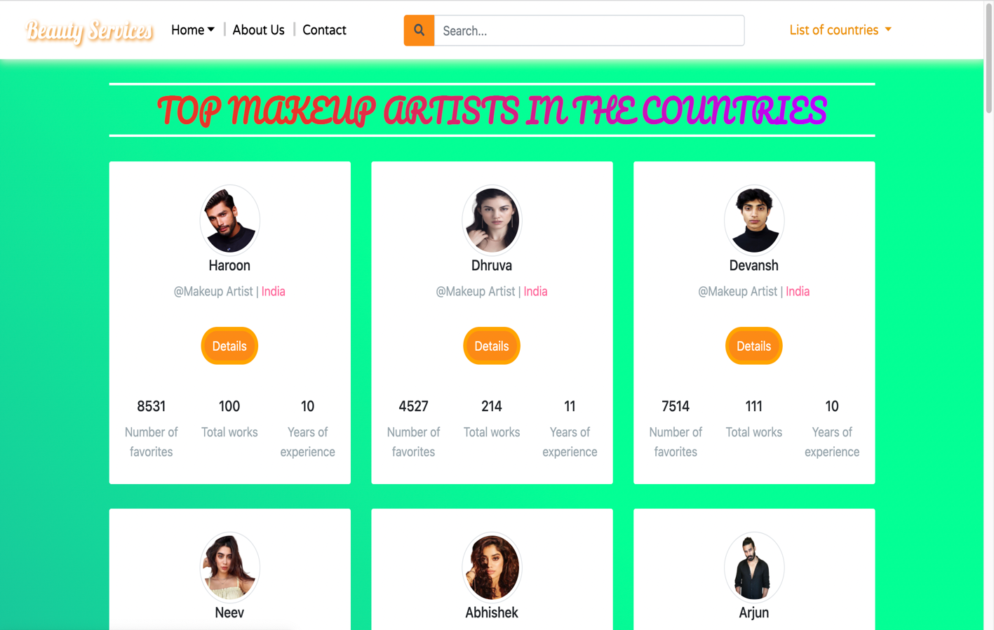**5.2 Makeup Artist**

**5.3 Details Page**

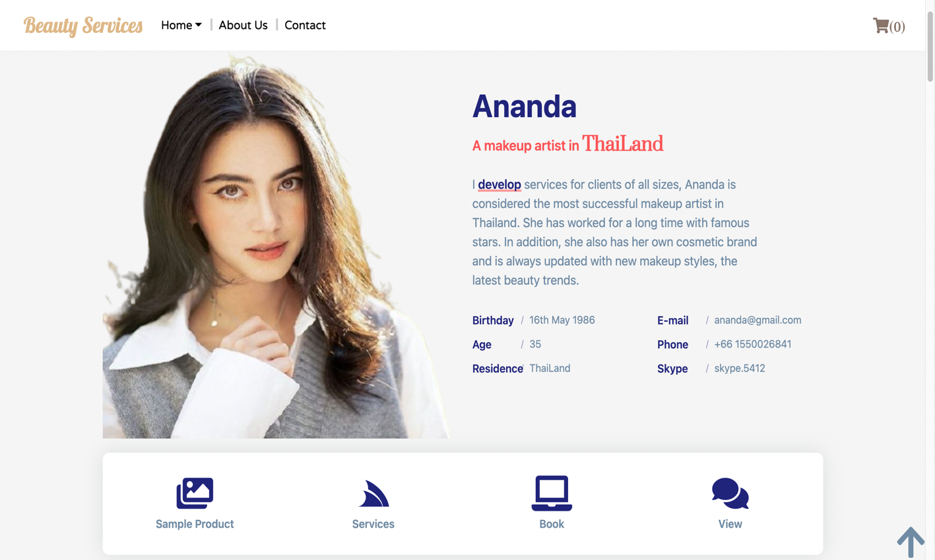

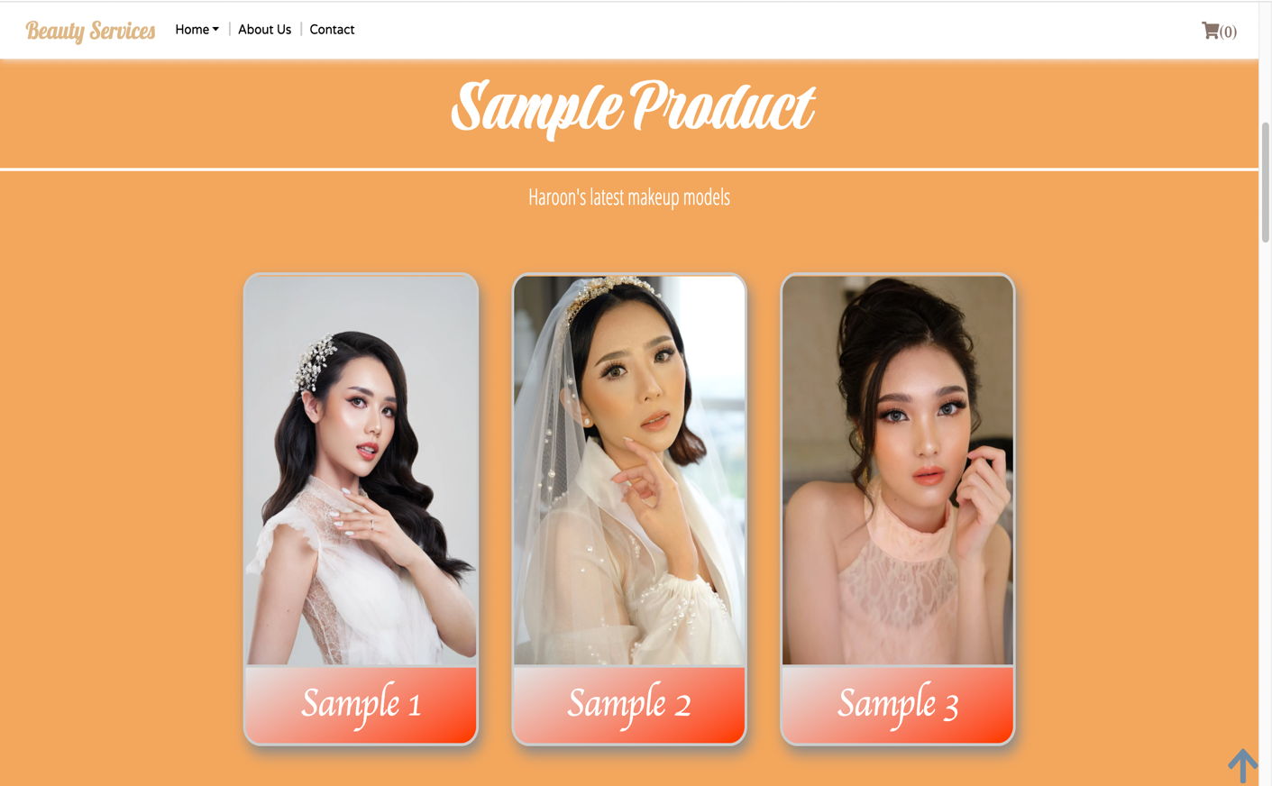

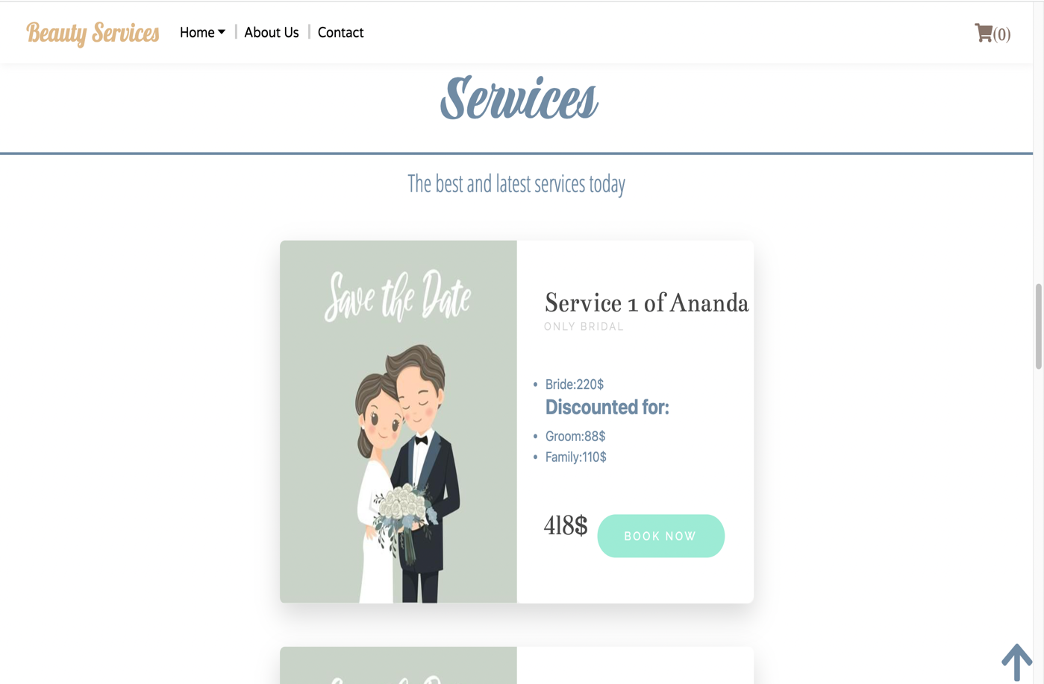



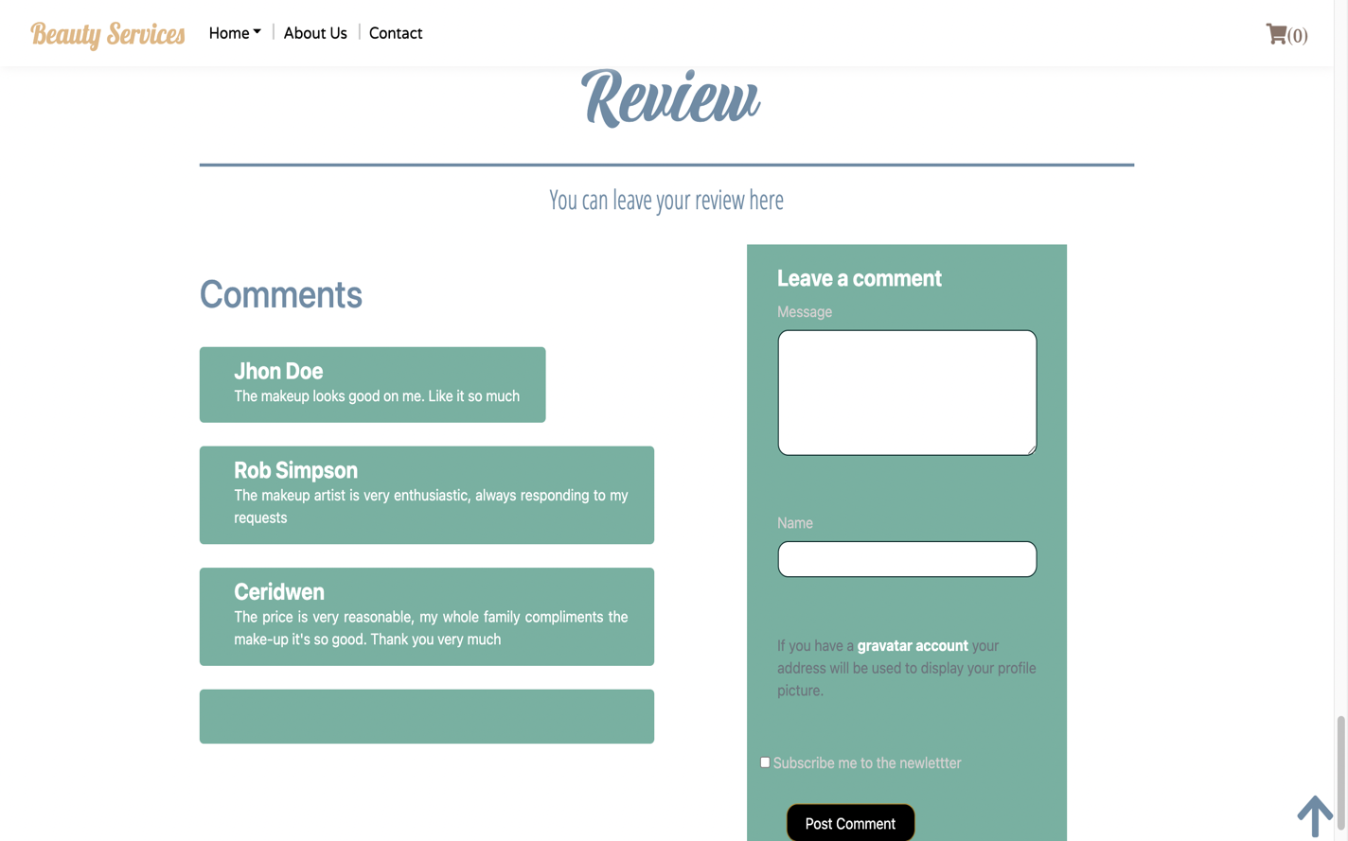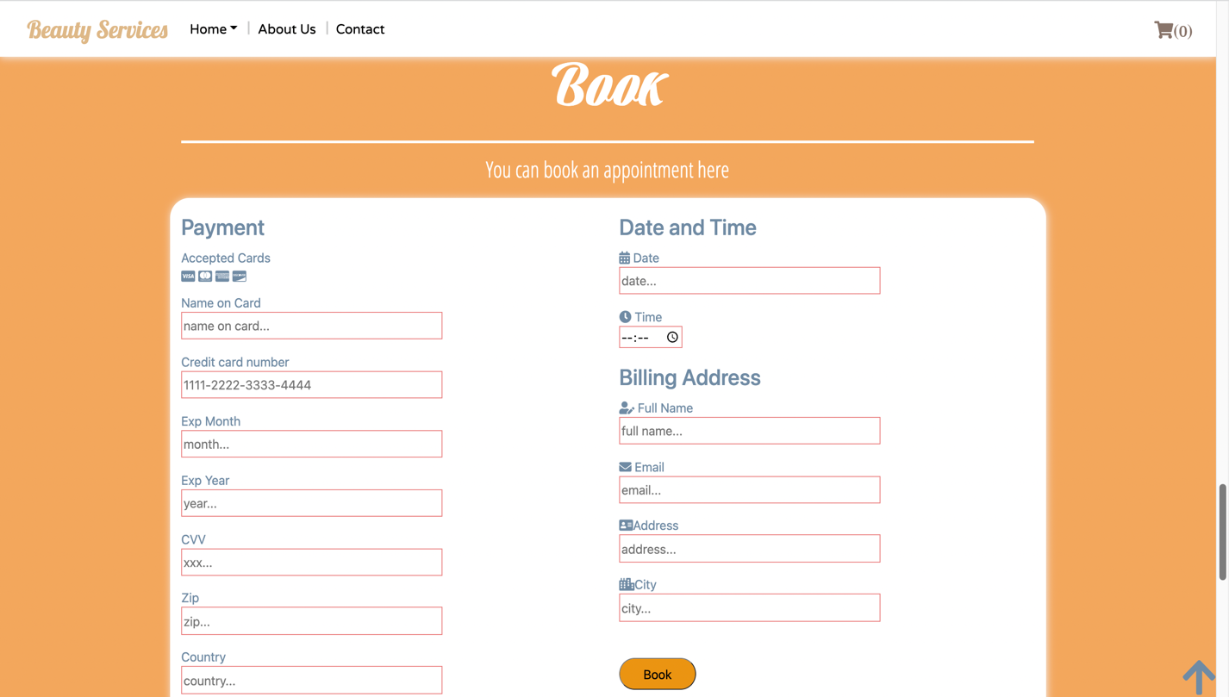

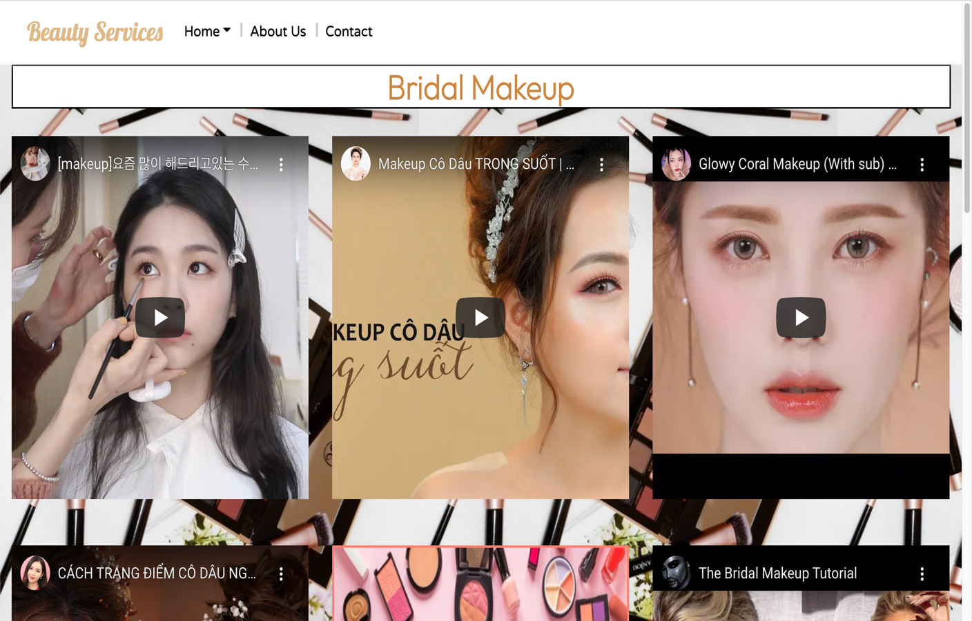**5.4 Video**

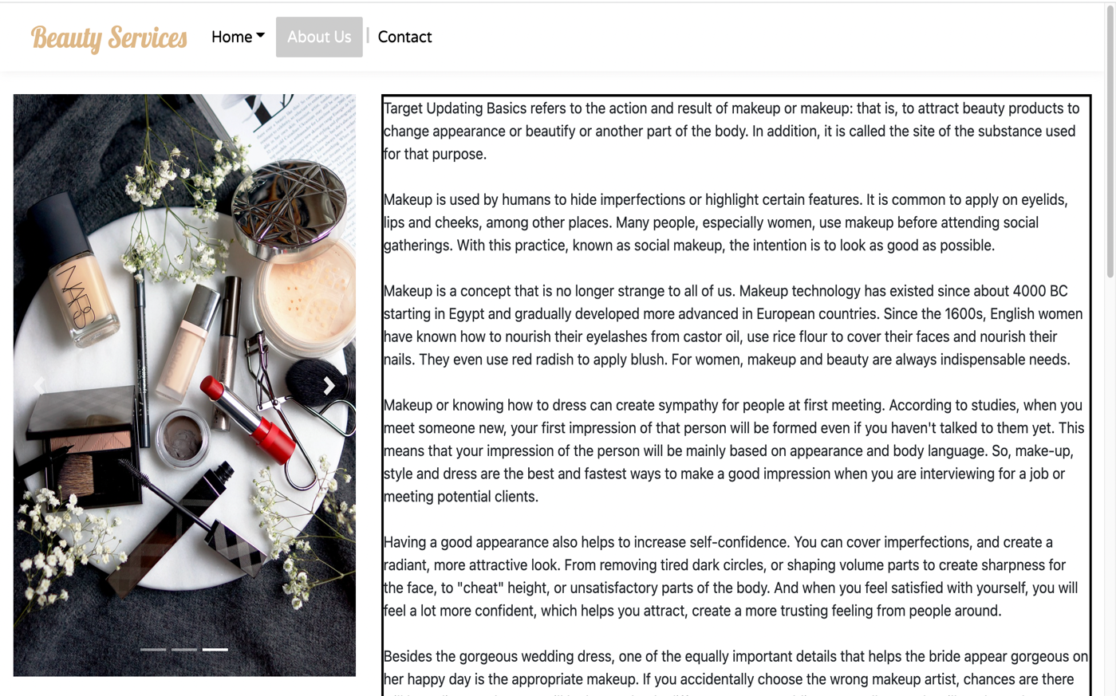**5.5 About Us**

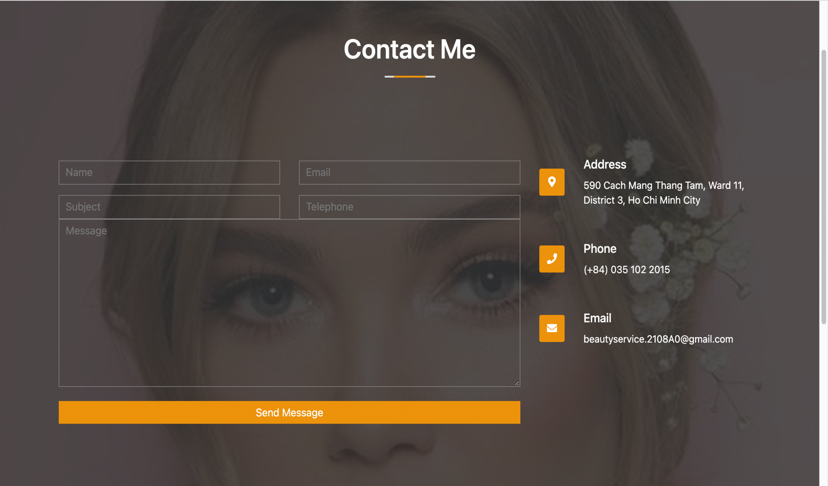**5.6 Contact**

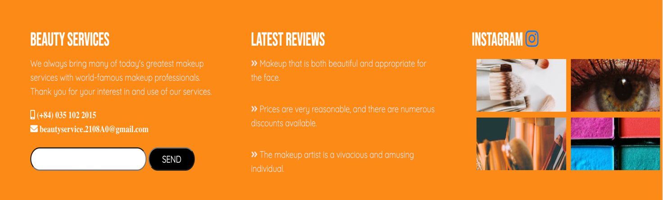**5.7 Footer**

**6 USER MANUAL**

**6.1 System Requirements:**

|  |  |  |
| --- | --- | --- |
| **NO.** | **Items** | **Description** |
| 1 | Operating System | Android, iOS, window 7 or higher |
| 2 | Browsers | Chrome, Firefox, Microsoft Edge, IE10+, Opera |

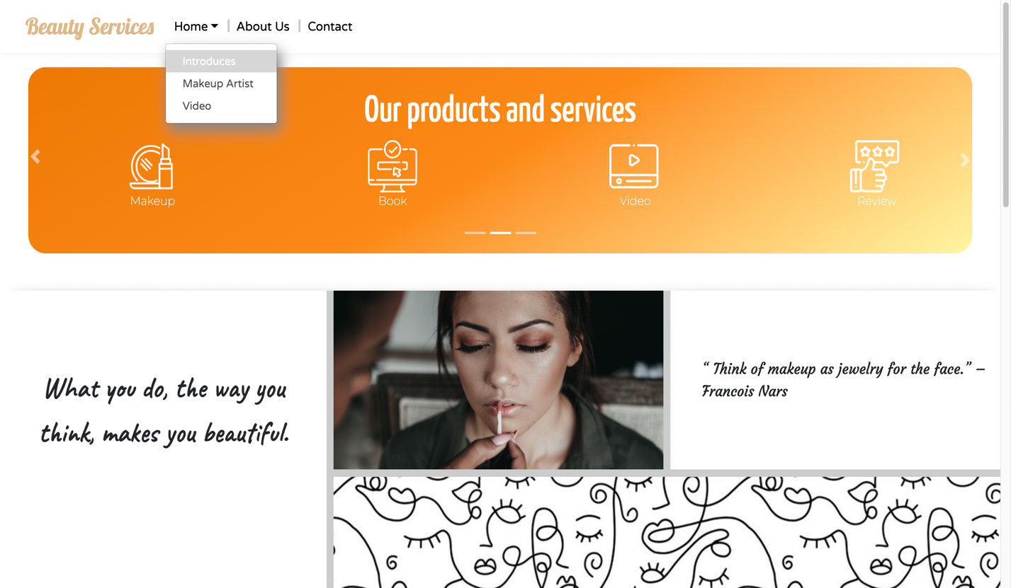**6.2 Step by Step Instructions:**

Side panel will have a functional search bar and several dropdown. Links to help with navigation.

**6.2.1 Starting Home Page:**

After clicking "Makeup Artist", it will take you to the makeup artists

After preload – users will have access to Home Page

pree

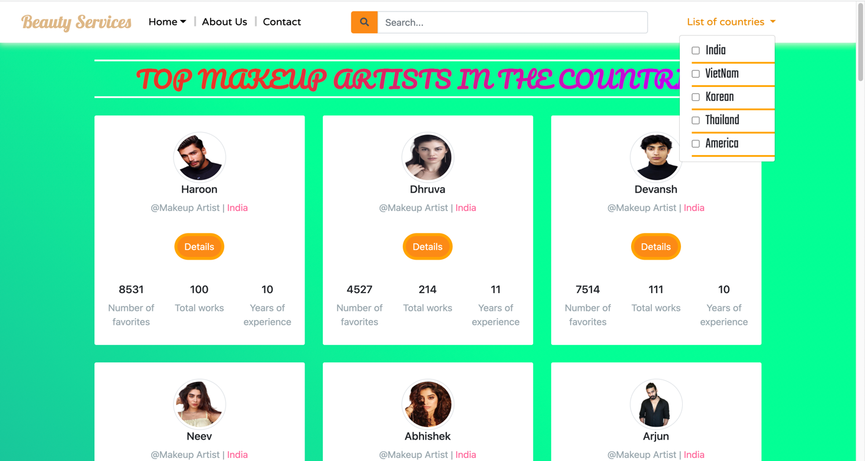**6.2.2 Makeup Artist Page**

If we do not know which country to find experts from, we have provided "List country" here.

In this search bar, we can search for different makeup artists

Here, we summarize some information of makeup artists

After you have selected the desired specialist, click "Details" to see more details.

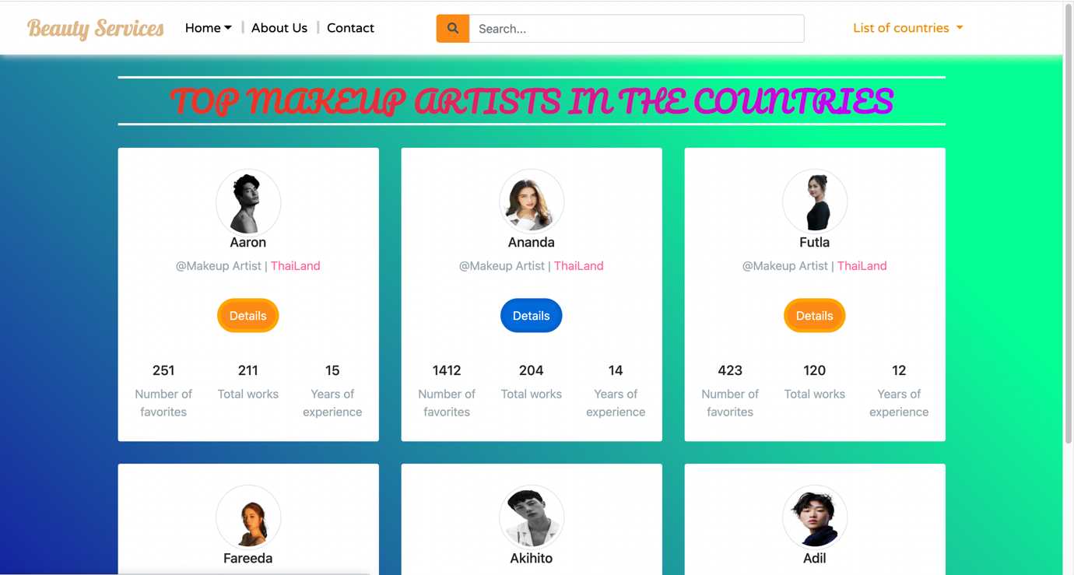

**6.2.3 Details Page**

Details about this specialist article are available here.

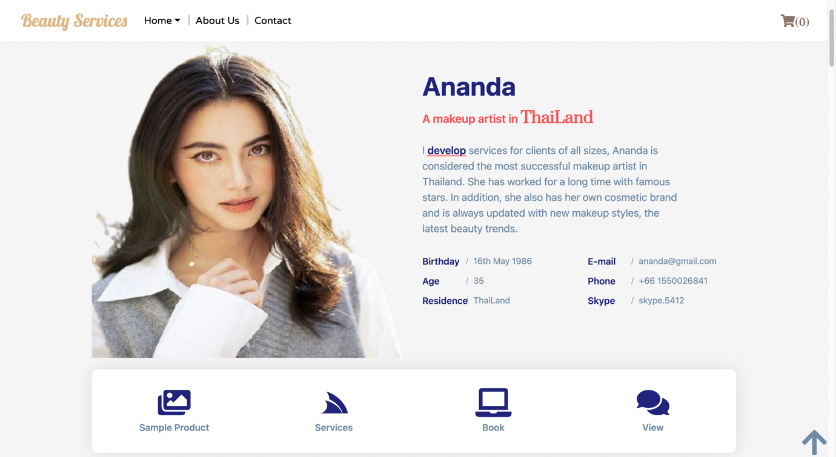

Next, are the services this makeup artist has. When you choose a service, the page will automatically go to that service for us.

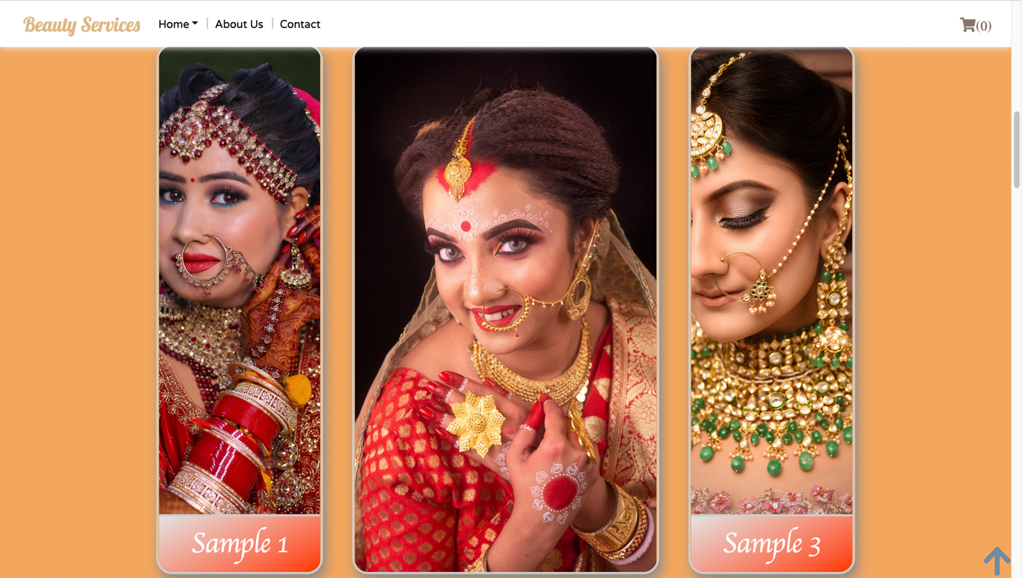

After clicking "Sample Product", the page will appear like this. Here, you can see the most prominent makeup samples of that makeup artist, to see clearly and the full picture you just need to hover over the image to enlarge.

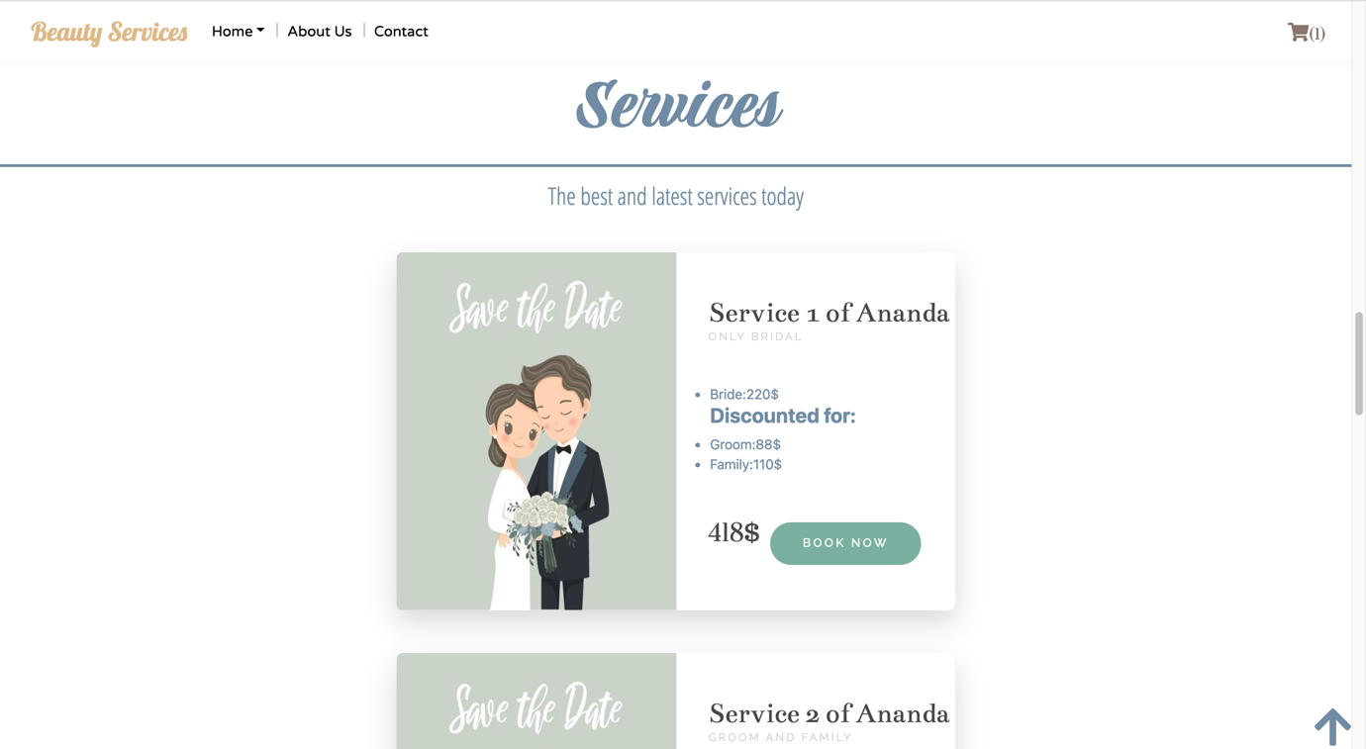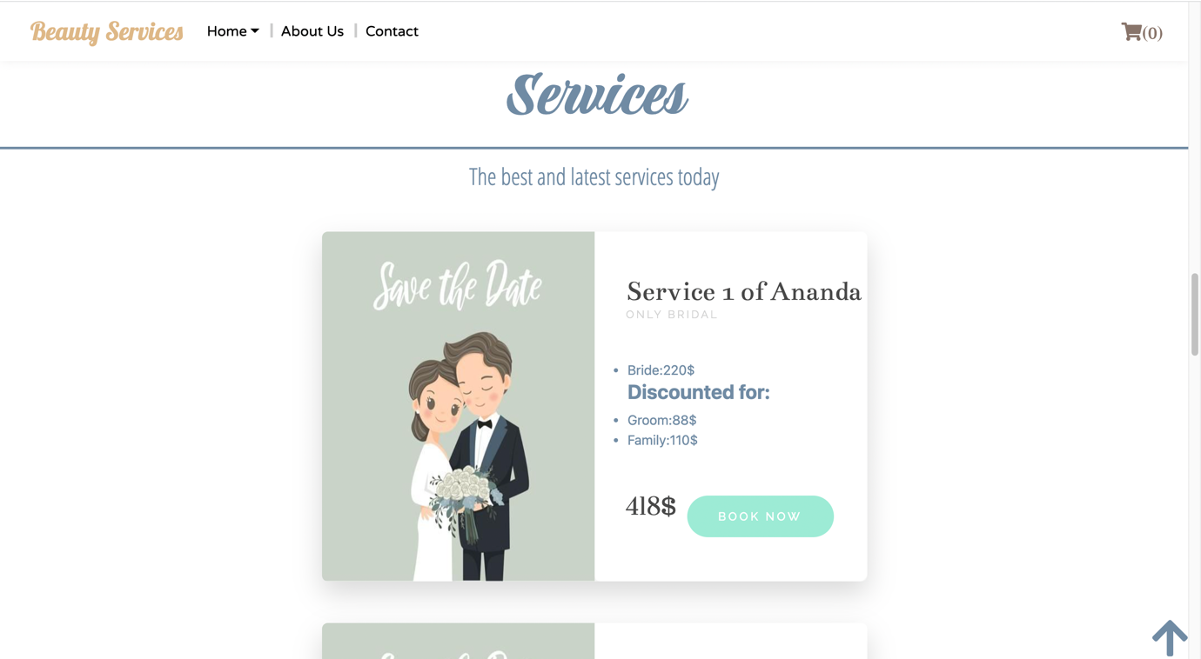

Once you have selected the service you want, click "book now" and the cart will show the number of services you choose.

The services of experts will be present here, users can choose the service they want.

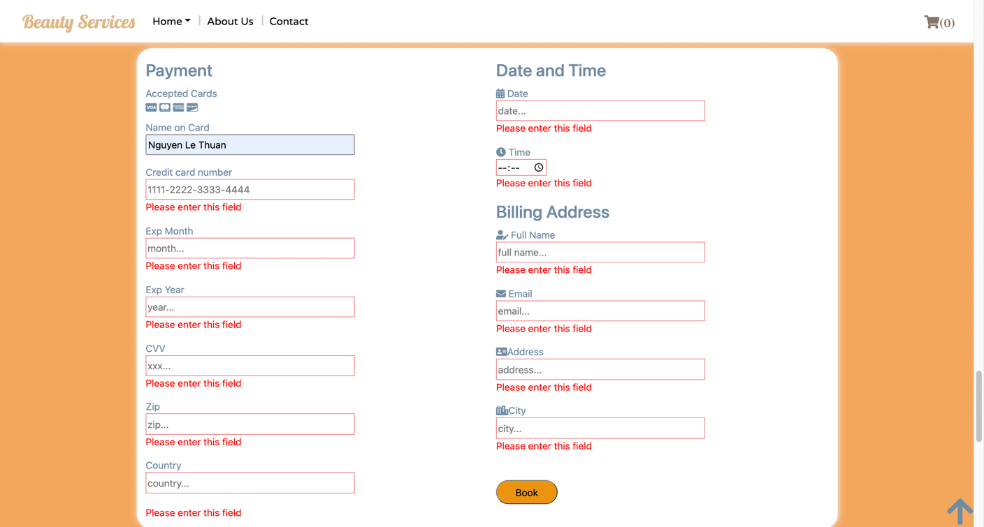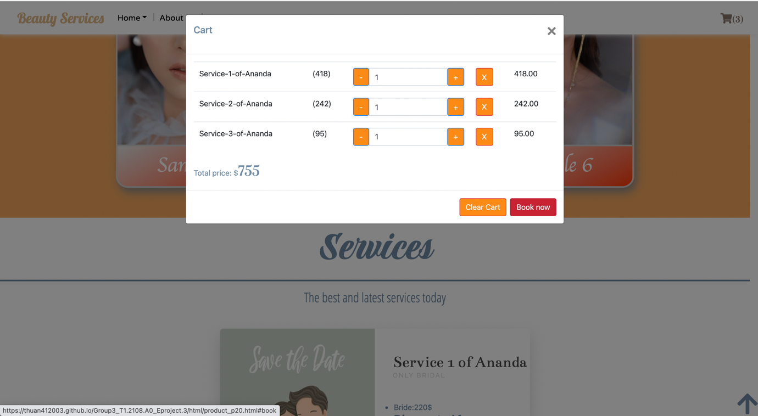

Fill it out completely and click "Book" and you have successfully booked an appointment.

Please fill in all the necessary information, this is mandatory, if you have filled it in but deleted it, the system will report an error immediately.

Once you've made your selection, to book an appointment, click "Book Now" to go to the "Book" service.

After you click on the cart, a control panel will appear for us, which has simple functions such as adding services or removing all services via the "Clear Cart" button.

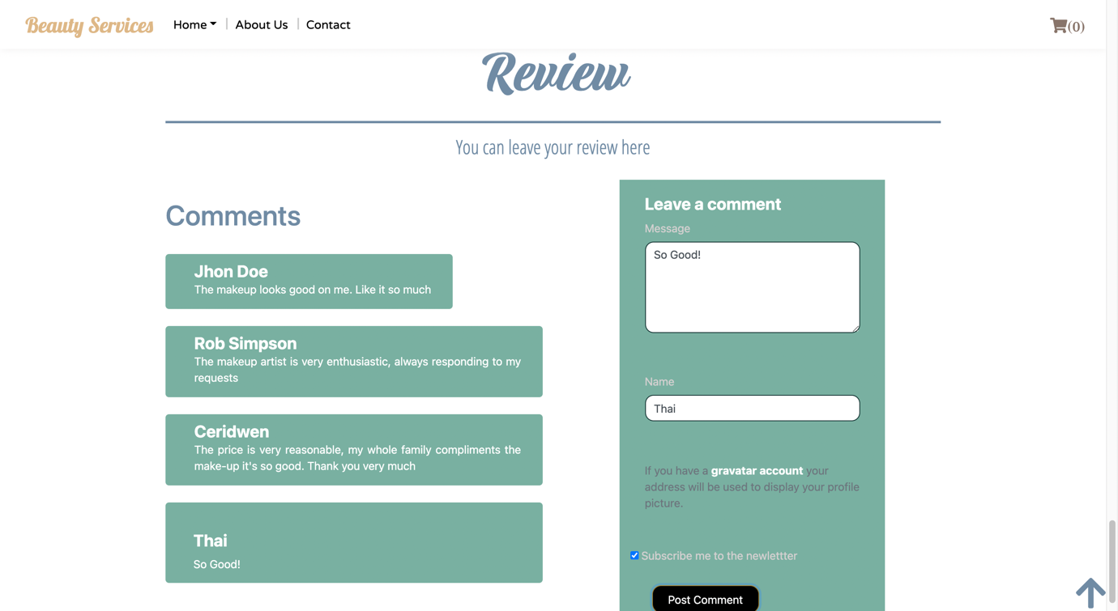

Here you can leave your comments about the makeup artist.

**6.2.4 Video Page**

You can watch makeup videos here.

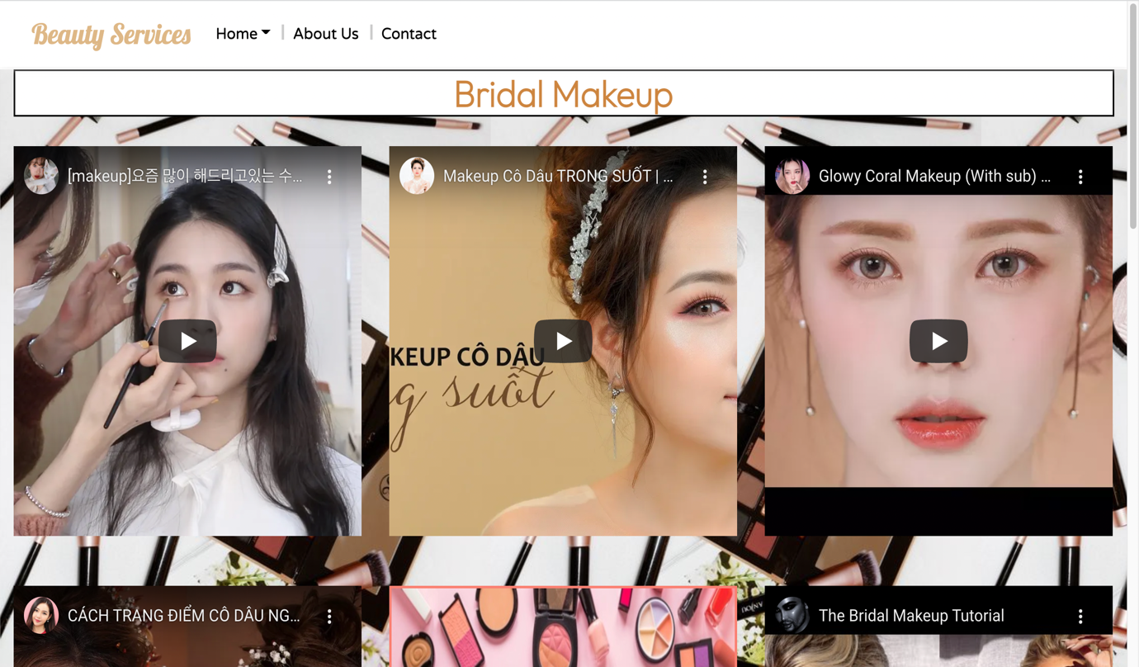**6.2.5 About Us**

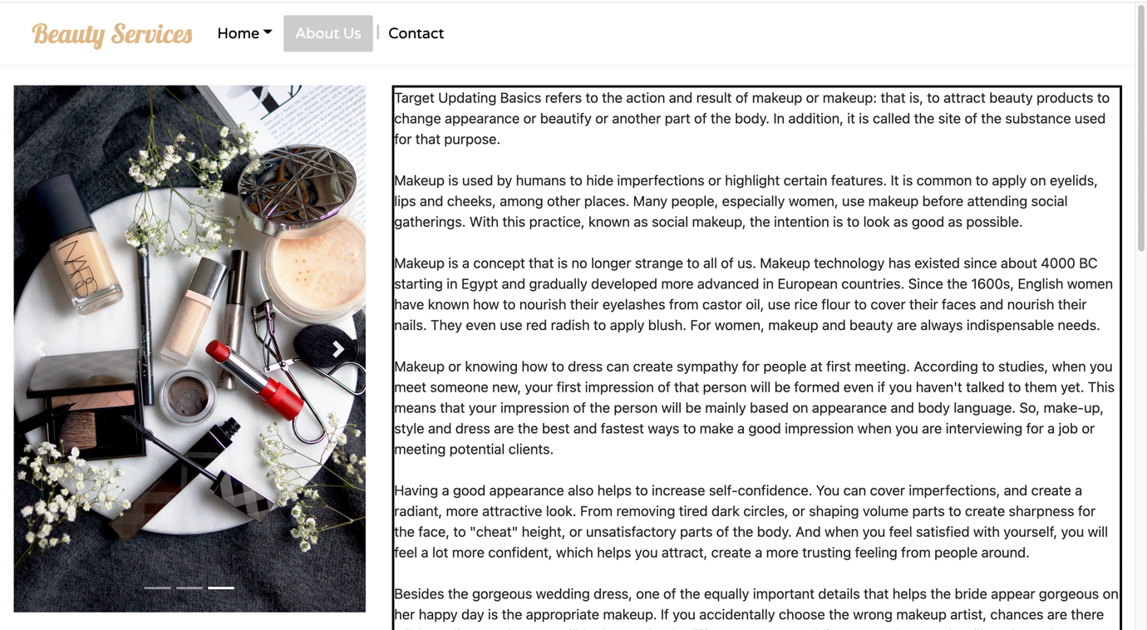

**6.2.6 Contact Us:**

The makeup shaping history and the meaning of the makeup site to the user

Users can contact us through the "Contact" page.

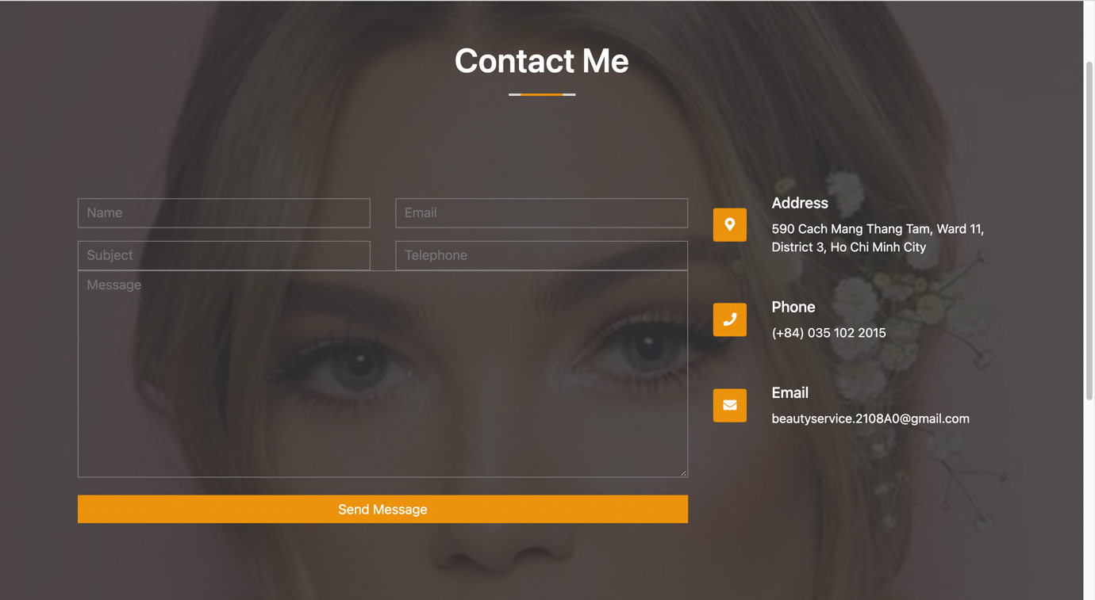

**6.2.7 Footer:**

More information about our website and company will be displayed in the footer session.

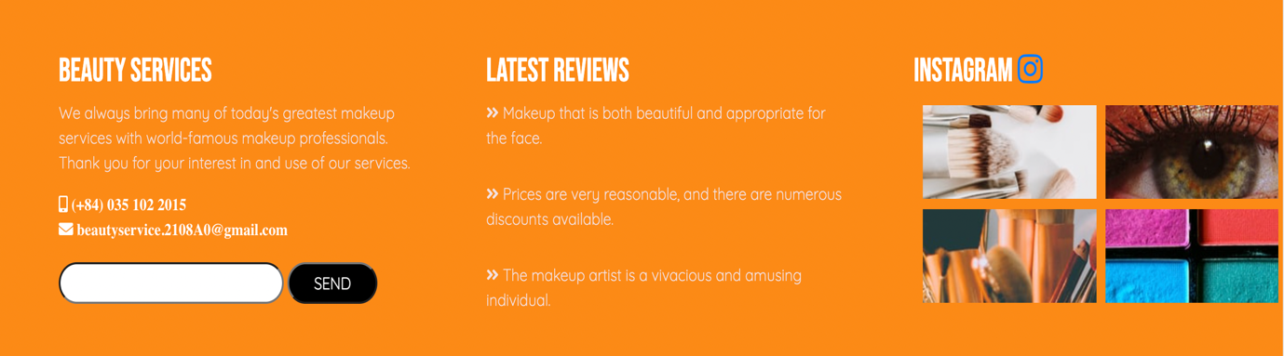

**7 TASK SHEET 2**

|  |  |  |  |  |  |  |
| --- | --- | --- | --- | --- | --- | --- |
| Project Ref No. | Project  Title - Ask  Me Mobile | Activity  Plan  Prepared  by | Date of preparation of Activity Plan | | | |
| Task | Actual  Start Date | Actual  Days | Teammate  Names | Status |
| Brainstorming ideas for  layouts, and Project Objective | | Thuận,Thái | 13/11/2021 | 4 days | Thuận,Thái | Completed |
| Draw site maps and  architecture design | | Thuận,Thái | 16/11/2021 | 1 day | Thuận,Thái | Completed |
| Wire framing general page  layout. | | Thuận,Thái | 17/11/2021 | 1 day | Thuận,Thái | Completed |
| Collect static assets (pictures,  mp4, documentation) | | Thuận,Thái | 17/11/2021 | 1 day | Thuận,Thái | Completed |
| Design & Build Home Page | | Thái | 16/11/2021 | 2 days | Thái | Completed |
| Design & Build Contact Us  Page | | Thuận | 16/11/2021 | 1 day | Thuận | Completed |
| Design & Build About Us Page | | Thuận | 16/11/2021 | 2 days | Trinh | Completed |
| Design & Build Footer Session | | Thái | 16/11/2021 | 2 days | Thái | Completed |
| Write project report Review 1  Activity | | Thuận | 18/11/2021 | 1 day | Thuận | Completed |
| Testing Ul. | | Thuận,Thái | 1/12/2021 | 5 days | Thuận,Thái | Completed |
| Testing Responsiveness. | | Thuận,Thái | 19/11/2021 | 10 days | Thuận,Thái | Completed |
| Final Testing | | Thái | 6/12/2021 | 5 days | Thái | Completed |
| Write project report Review 2 | | Thuận | 7/12/2021 | 2 day | Thuận | Completed |